Bluetooth Hacking

# **Lab Objectives**  
1. Understand Bluetooth communication fundamentals and security protocols.  
2. Simulate common Bluetooth attacks using virtual tools.  
3. Analyze captured Bluetooth traffic and identify vulnerabilities.  
4. Demonstrate ethical hacking principles to improve Bluetooth security.

---

## **Lab Prerequisites**  
1. A computer with the following installed:  
   - **Wireshark**: For Bluetooth traffic analysis.  
   - **Python**: For scripting and decoding Bluetooth packets.  
   - **Kali Linux**: Includes Bluetooth hacking tools like `Bluetoothctl`, `Bluelog`, and `BtleJuice`.  
   - **Virtualization Software**: VirtualBox or VMware for running virtual machines.

2. Pre-captured Bluetooth traffic datasets:  
   - Example sources: [PacketTotal](https://packettotal.com) or GitHub repositories.  
   - Example file formats: `.pcap` or `.pcapng` containing Bluetooth Low Energy (BLE) or classic Bluetooth traffic.

https://wiki.wireshark.org/Bluetooth

3. Knowledge of Bluetooth protocols:  
   - Bluetooth Classic (BR/EDR)  
   - Bluetooth Low Energy (BLE)

---

## **Lab Exercises**

### **Exercise 1: Analyzing Bluetooth Traffic Using Wireshark**

#### **Objective**:  
Learn how to open and analyze Bluetooth communication traffic.

#### **Steps**:  
1. **Open Wireshark**:  
   - Launch Wireshark on your computer.  
   - Load a pre-captured Bluetooth dataset (`.pcap` file).

2. **Apply Filters**:  
   - Use filters specific to Bluetooth protocols:  
     - For classic Bluetooth: `bthci_evt`, `bthci_acl`  
     - For BLE: `btatt`, `btcommon`, `btmesh`

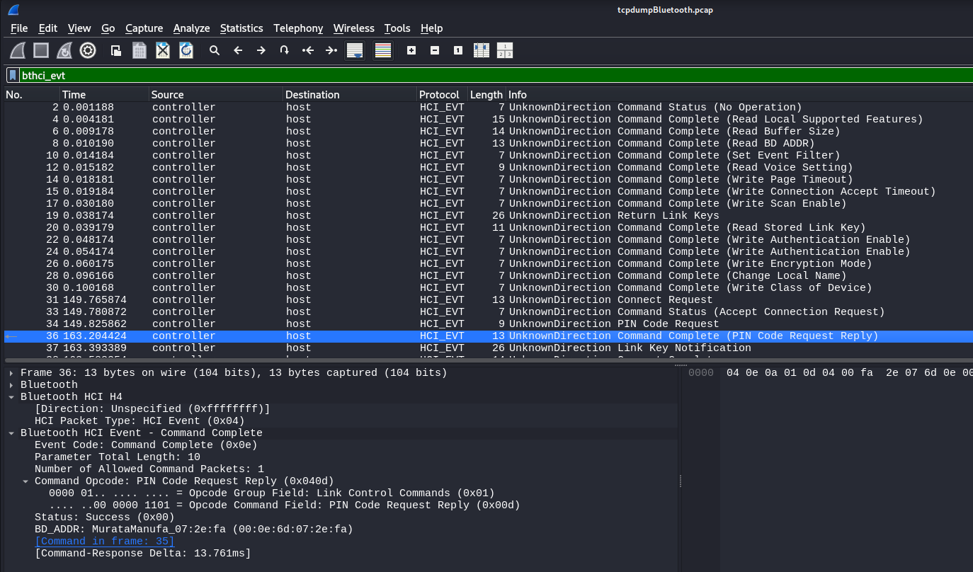

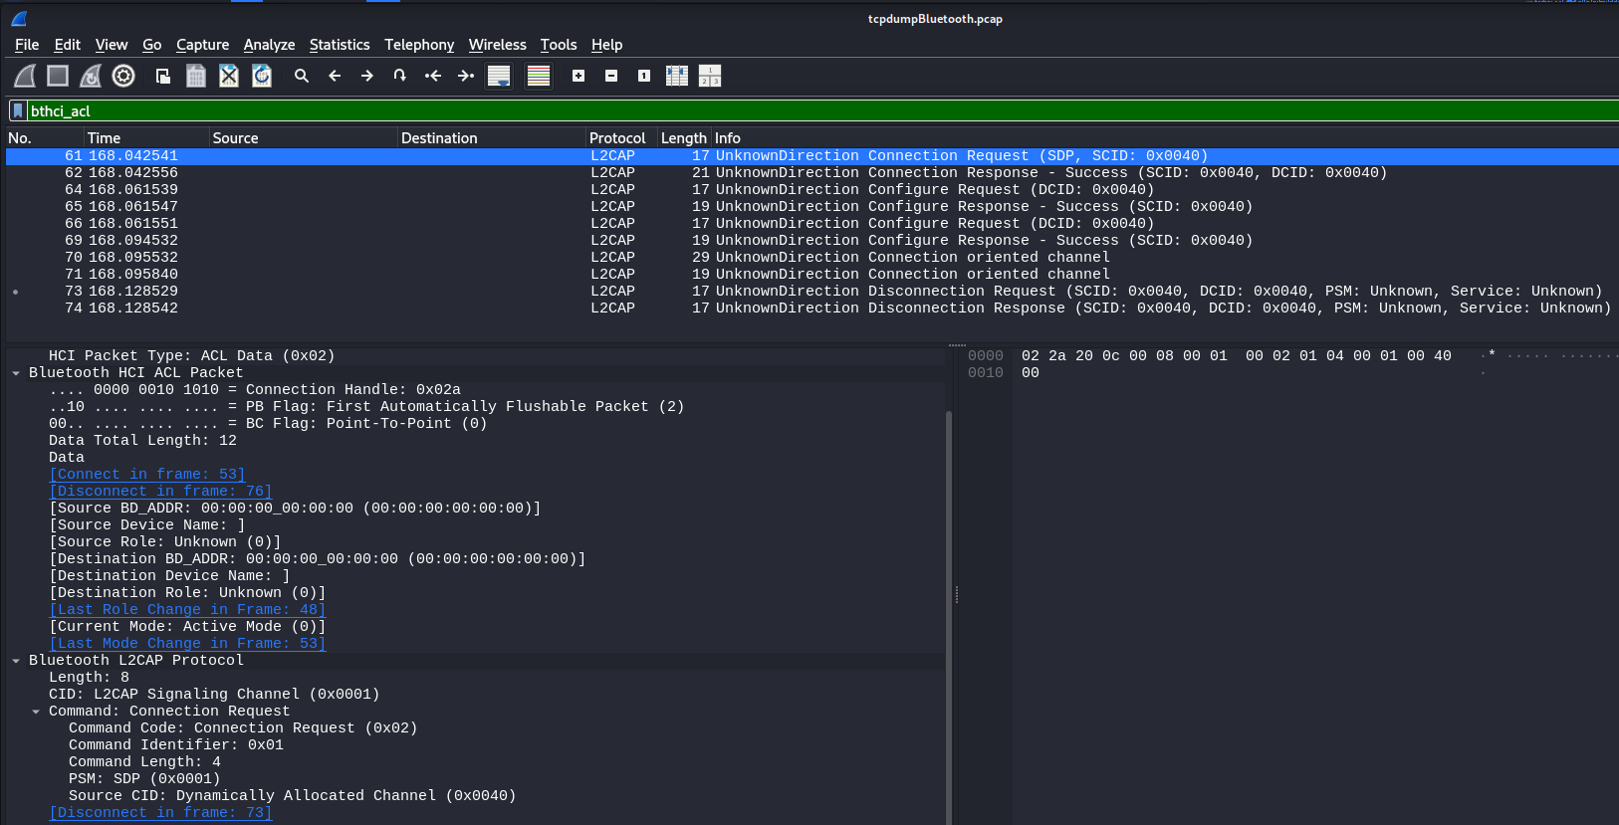

3. **Analyze Packets**:  
   - Identify key elements of Bluetooth communication:  
     - **Device Pairing**: Look for packets involving `L2CAP` (Logical Link Control and Adaptation Protocol).

     - **Service Discovery**: Look for `SDP` (Service Discovery Protocol).  
     - **Data Transmission**: Examine `ATT` (Attribute Protocol) or `ACL` (Asynchronous Connection-Less) packets.

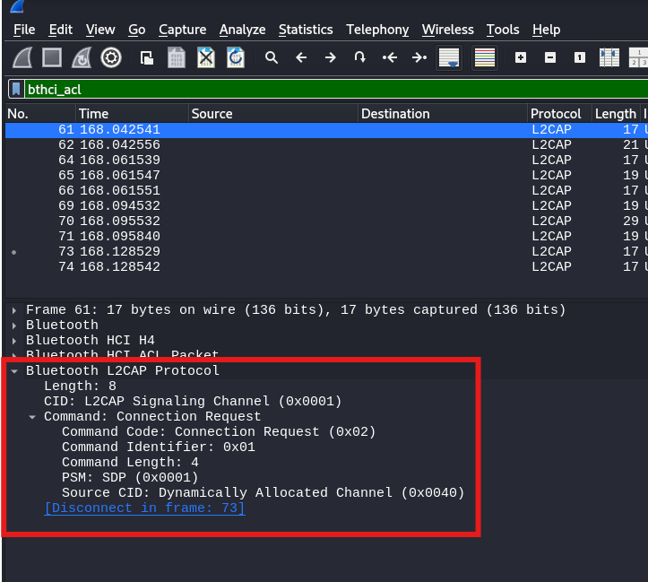 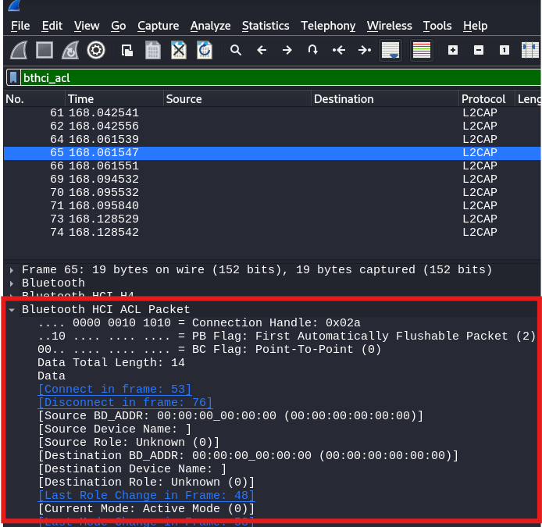

4. **Document Observations**:  
   - Note the MAC addresses, pairing methods, and any security mechanisms in use.

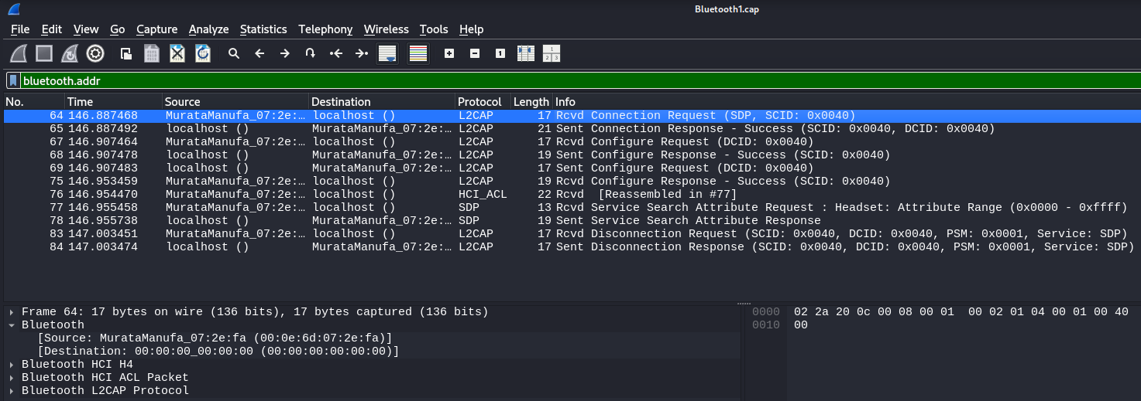

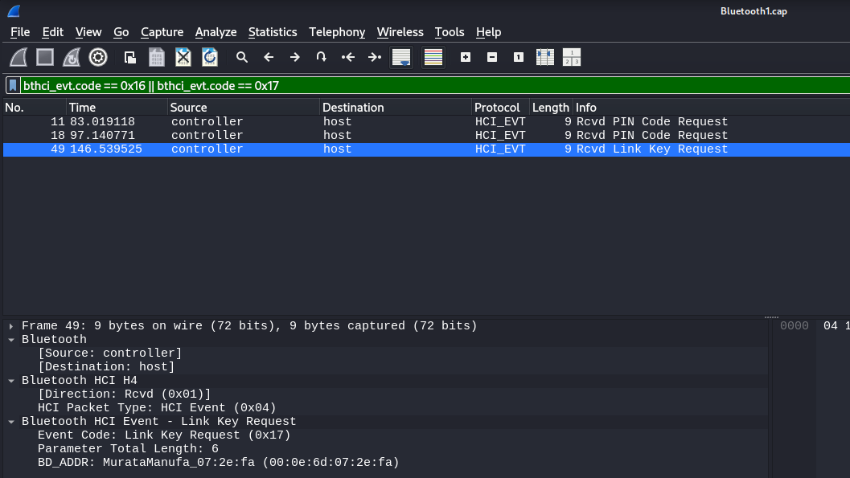

#### **Expected Outcome**:  
Students will understand the basic structure of Bluetooth packets and how to analyze communication flows.

---

### **Exercise 2: Simulating a Bluetooth Device Scan**

#### **Objective**:  
Simulate a Bluetooth scanning process to identify nearby devices (theoretical without hardware).

#### **Steps**:  
1. **Setup**:  
   - Launch Kali Linux in a virtual machine.  
   - Open a terminal.

2. **Simulate Device Scanning**:  
   - Use `hcitool` to simulate device scanning commands (theoretical):  
     ```bash  
     hcitool scan  
     ```  
   - Discuss how scanning works by identifying discoverable devices and their MAC addresses.

3. **Alternative Visualization**:  
   - Use pre-recorded datasets showing scans and pairings.  
   - Analyze results with Wireshark or Python scripts.

#### **Expected Outcome**:  
Students will understand how scanning identifies devices and the potential security risks.

---

### **Exercise 3: Replay Attack Simulation Using Pre-Captured Data**

#### **Objective**:  
Simulate a replay attack using pre-captured Bluetooth packets.

#### **Steps**:  
1. **Understand Replay Attacks**:  
   - Discuss how attackers capture and retransmit packets to mimic legitimate devices.

2. **Set Up**:  
   - Use a pre-captured `.pcap` file containing a pairing process or data exchange.

3. **Analyze the Dataset**:  
   - Open the dataset in Wireshark.  
   - Identify critical packets used in pairing or communication.

4. **Simulate a Replay**:  
   - Discuss how tools like `BtleJuice` or Python scripts can replay packets in a real environment.  
   - Without hardware, focus on the theoretical implications and packet structures.

#### **Expected Outcome**:  
Students will understand how replay attacks exploit weak security mechanisms and the importance of robust encryption.

---

### **Exercise 4: Simulating a MITM Attack Using BtleJuice (Theoretical)**

#### **Objective**:  
Understand the concept of a Man-in-the-Middle (MITM) attack in Bluetooth communication.

#### **Steps**:  
1. **Overview of BtleJuice**:  
   - Learn about BtleJuice, a tool used for intercepting and modifying BLE communication.

2. **Simulate the Attack**:  
   - Discuss how BtleJuice creates a proxy between two devices.  
   - Analyze pre-captured datasets showing MITM interactions.

3. **Defensive Measures**:  
   - Highlight how secure pairing methods (e.g., Just Works, Numeric Comparison) mitigate MITM risks.

#### **Expected Outcome**:  
Students will gain theoretical knowledge of MITM attacks and their prevention.

---

## **Lab Summary**  
1. **Skills Acquired**:  
   - Bluetooth packet analysis.  
   - Understanding of scanning, pairing, and data exchange processes.  
   - Awareness of replay and MITM attack mechanisms.

2. **Key Takeaways**:  
   - Bluetooth communication is susceptible to various attacks without proper security mechanisms.  
   - Ethical hacking ensures that vulnerabilities are addressed to strengthen Bluetooth security.

---

## **Additional Resources**  
1. **Capture Files**:  
   - Public repositories like [PacketTotal](https://packettotal.com) or GitHub.  
2. **Bluetooth Documentation**:  
   - Official Bluetooth specifications: [[https://www.bluetooth.com/specifications/](https://www.bluetooth.com/specifications/).](https://www.bluetooth.com/specifications/%5d(https:/www.bluetooth.com/specifications/).)  
3. **Tutorials**:  
   - Kali Linux Bluetooth tools: [[https://kali.org/](https://kali.org/).](https://kali.org/%5d(https:/kali.org/).)  
   - Wireshark documentation: [[https://www.wireshark.org/docs/](https://www.wireshark.org/docs/).](https://www.wireshark.org/docs/%5d(https:/www.wireshark.org/docs/).)

By following this manual, students can gain valuable insights into Bluetooth hacking techniques and the importance of secure implementations, even without physical hardware. Let me know if you need further clarification or additional exercises!